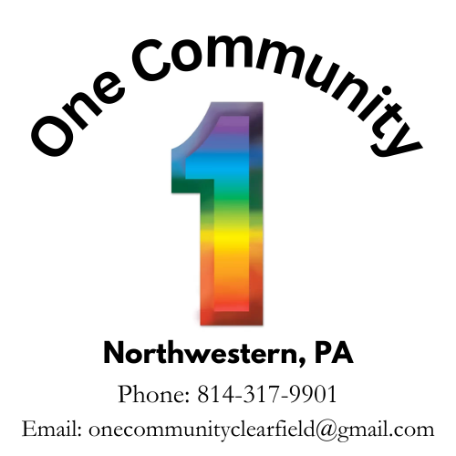

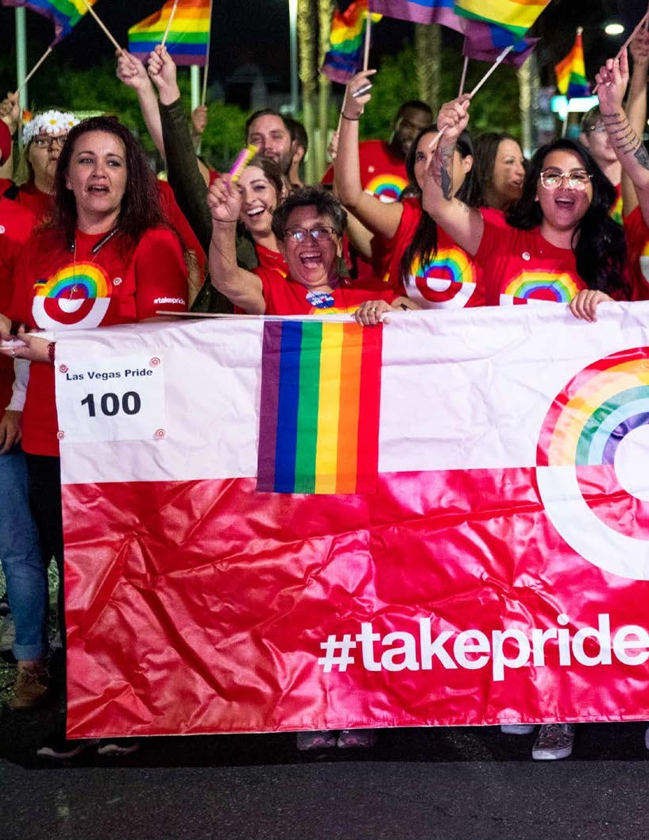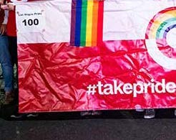

ONE COMMUNITY

SUPPORT THE COMMUNITY & PROMOTE YOUR BUSINESS
As one of Northwestern Pennsylvania only lesbian, gay, bisexual, and transgender (LGBT) organization, we are pleased to invite you to become a sponsor of our “One Community” Pride Festival. PRIDE Events will be held Jun 4 2025, until June 8 2025. PRIDE Events will be hosted throughout the month of June (also National LGBT Pride Month). Our PRIDE celebration will bring together voices of our community members as they contribute their performances. Despite being rural, we hope to celebrate PRIDE and bring our community together.

DISTRIBUTION & LONG SHELF-LIFE GET RESULTS
A full-color program guide will be distributed extensively one month prior to the event throughout Northwestern Pennsylvania and surrounding locations and select cities across Pennsylvania. The PRIDE program has a shelf life! This means it delivers your advertising often, creating an excellent branding opportunity for your business. Additionally, it’s a souvenir that will remind expected attendees of your contribution and commitment to support the community. As research indicates, the LGBT community is loyal to those who support them! Our virtual format will reach unique views in the first 10 days from launch, and this digital format will live on generating continued attention and impressions.

BUILD CUSTOMER AWARENESS & LOYALTY
Being a sponsor with “One Community” PRIDE provides a tremendous amount of exposure for your business to the community and our allies. Each year, the PRIDE Celebration and other events are not only spectacular events for the attendees, but an amazing experience for those who assist in making it happen. Your support increases awareness for all.

One Community PRIDE looks forward to working with you as a sponsor of the PRIDE Celebration and a most colorful civic event!

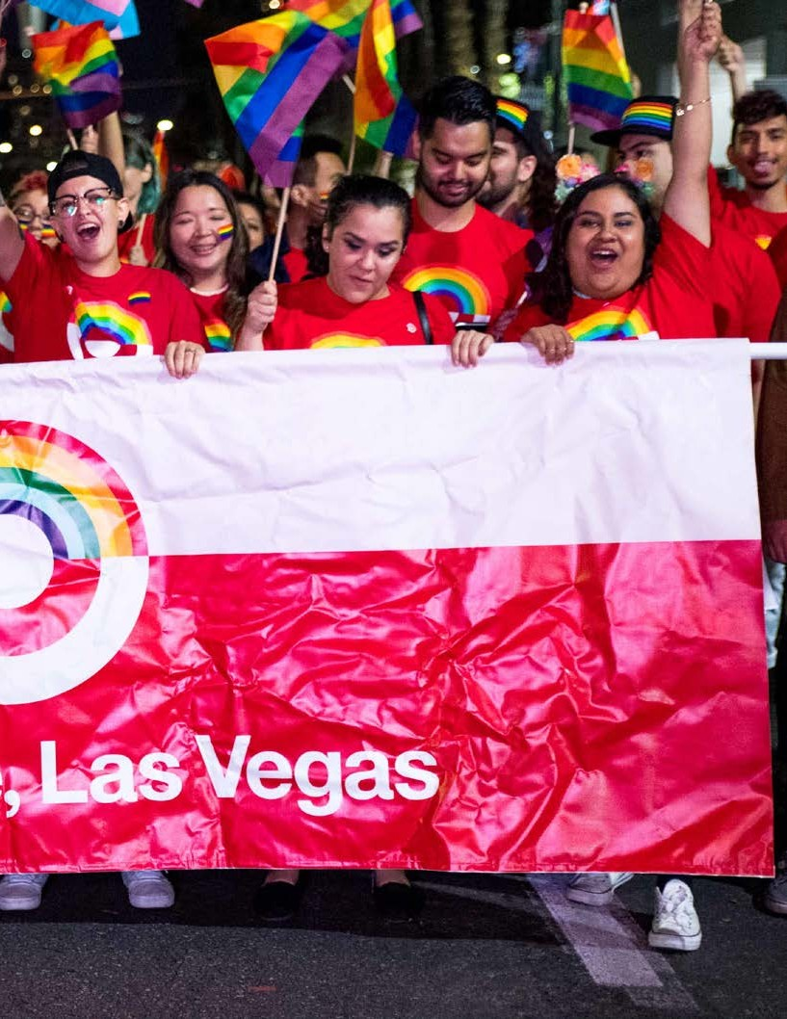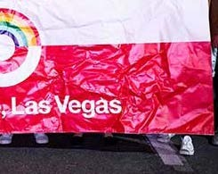

The PRIDE celebration provides an opportunity for you to reinforce your brand in a significant media market, to the extremely “brand loyal” LGBT community. The PRIDE celebration is the best opportunity in North West Pennsylvania for your business to reach this important consumer.

One Community Pride will attract a very diverse audience, comprising people aged 5 to 95, men, women, and children; singles, couples, families; gays, lesbians, bisexuals, transgendered, and their straight allies. The 2025 One Community Pride Festival expects to see over 1000 people in attendance both County residents as well as tourists from around Pennsylvania will join us for the events.

Become a sponsor today to enjoy the benefits of our fully integrated sponsorship packages. Receive guaranteed visibility in local, regional, and state print advertising as well as a presence at the PRIDE Festival and all Pride events. PRIDE Sponsorships are priced to encourage participation by businesses of all sizes.

THANK YOU!
We look forward to answering any of the questions you may have regarding potential sponsorship opportunities.

YOUR SPONSORSHIP COMMITTEE
Phone (814) 317-9901
Email onecommunityclearfield@gmail.com

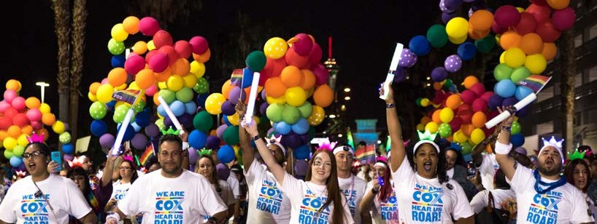Customized benefits limited to one cash sponsor. Presenting Sponsor recognition for One Community Pride.
Diamond
EVENT SPONSOR
$500+

Presenting sponsor recognition added to One Community PRIDE logo for the duration of the agreement.

BRAND EXPOSURE
Logo placement on applicable future state/regional/local magazine advertisements, posters/banners, e-mail newsletters. (Sponsor to provide all artwork / logos), also included subsequent in One Community PRIDE Program sponsor “Thank You” page.

One Community web brand - Logo placement on sponsor page, title slide on home page.

2- Branded Event spots at any 2025 One Community events.

4 – Promotional branded swag bags

T-Shirt – Branded Logo on One Community annual t-shirt (Sponsor to provide all artwork / logos)

SOCIAL MEDIA
Acknowledgement in six future unique individual social media posts through 2023. (Sponsor to provide all artwork / logos)

*Please Note: Only sponsor commitments made and paid in full by April 15, 2025 carry guaranteed inclusion in applicable regional and state advertising – per sponsor benefits.

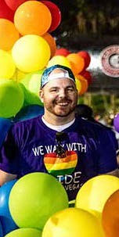

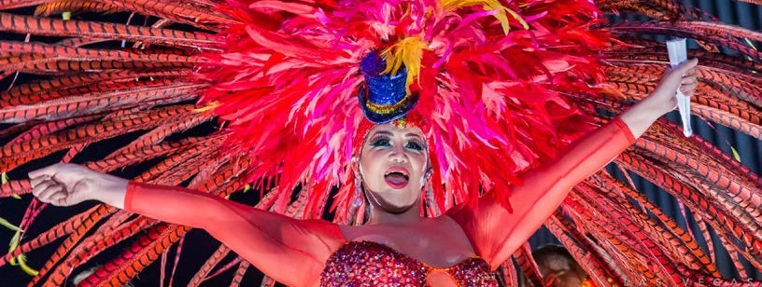
Gold
EVENT SPONSOR
$200+

BRAND EXPOSURE
Logo placement on applicable future state/regional/local magazine advertisements,
posters/banners, e-mail newsletters. (Sponsor to provide all artwork / logos), also included
subsequent in One Community PRIDE Program sponsor “Thank You” page.

One Community web brand - Logo placement on sponsor page, title slide on home page.

1- Branded Event spots at any 2025 One Community events.

2 – Promotional branded swag bags

T-Shirt – Branded Logo on One Community annual t-shirt
(Sponsor to provide all artwork / logos)

*Please Note: Only sponsor commitments made and paid in full by April 15, 2025, carry guaranteed inclusion in applicable regional and state advertising – per sponsor benefits.

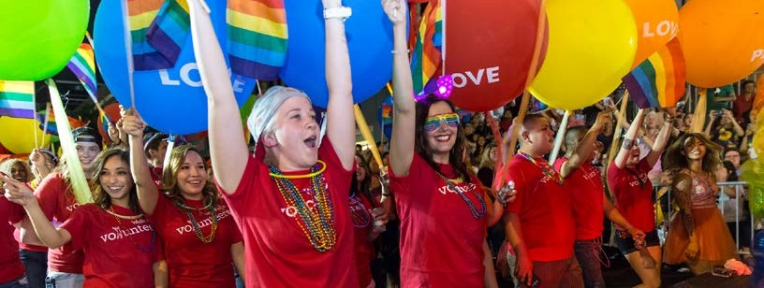
Local Partner
EVENT SPONSOR
$500+ IN CASH

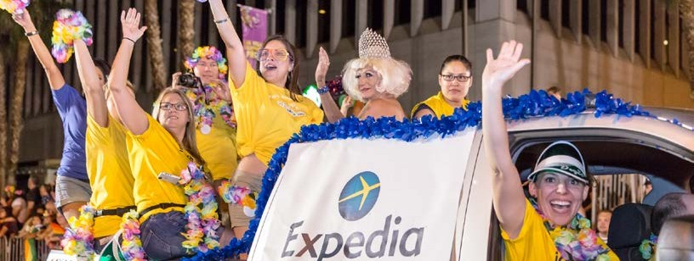
YELLOW
EVENT SPONSOR
$6,000+ IN CASH

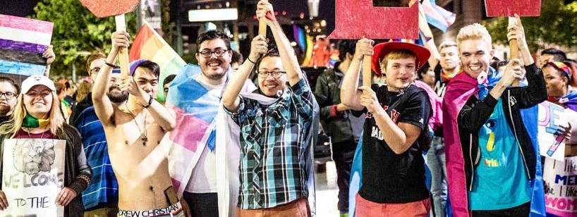
Local Partner
EVENT SPONSOR
$100 + IN CASH
BRAND EXPOSURE
Logo placement on applicable future state/regional/local magazine advertisements,
posters/banners, e-mail newsletters. (Sponsor to provide all artwork / logos), also included
subsequent in One Community PRIDE Program sponsor “Thank You” page.

1- Branded Event spots at any 2025 One Community events.

1 – Promotional branded swag bags

*Please Note: Only sponsor commitments made and paid in full by April 15, 2025, carry guaranteed inclusion in applicable regional and state advertising – per sponsor benefits.

Media sponsor levels are based on the value of media coverage available. *

DIAMOND Media- $300
- Diamond level logo placement
- One full-page in the PRIDE Guide
- Publication placement
- Three Facebook postings on Facebook page during the week of PRIDE

GOLD Media- $200
- Gold level logo placement
- One half-page in the PRIDE Guide
- Publication placement
- Two Facebook postings on Facebook page during the week of Pride.

SILVER- $100
- Silver level logo placement
- Publication placement
- One Facebook postings on Facebook page during the week of PRIDE

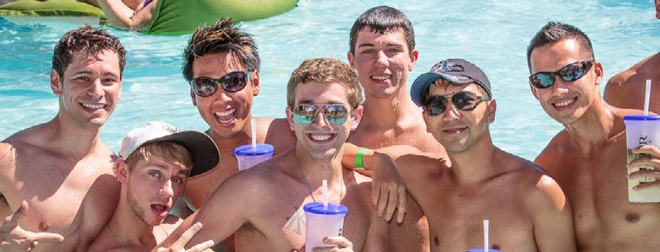

MEDIA SPONSOR LEVELS

*Please Note: Only sponsor commitments made and paid in full by April 15, 2025 carry guaranteed inclusion in applicable regional and state advertising – per sponsor benefits.

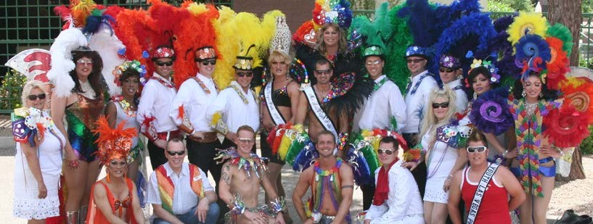Completed Sponsorship Agreement and complete Sponsorship must be postmarked no later than April 15, 2025*.

DEADLINES
SPONSORSHIP DUE DATES

Please make checks payable to One Community Northwestern PA PrideFest Cash sponsorships will be credited at full value, in kind sponsorships will be credited at 1/2 market value for intangible goods and market value for tangible goods.

Send Agreement and Sponsorship to:

226 North Second Street

Clearfield, PA 16830
(You will be notified upon receipt of your Sponsorship)

Logos in JPG, PNG, PDF, SVG, GIF, format should be sent to info@onslowcountylgbtq.com as soon as possible, but no later than May 1, 2025.

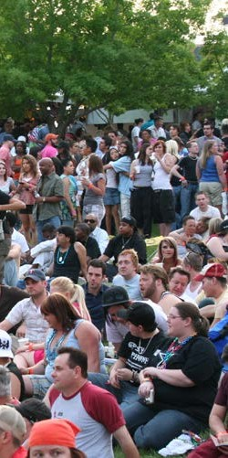
*Please Note: Only sponsor commitments made and paid in full by May. 1, 2025, carry guaranteed inclusion in applicable regional and state advertising – per sponsor benefits.

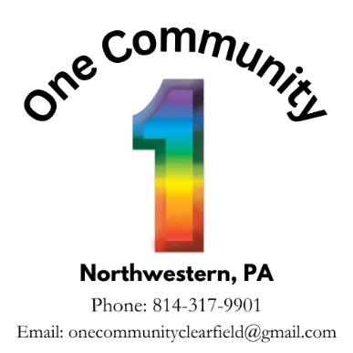
Sponsorship Form

Please check those that apply:
- Diamond Sponsorship Amount $__________________
(Reserve by April 30, 2025 / Ad(s) due by May 1st)
- Gold Sponsorship Amount $__________________
(Reserve by April 30, 2025 / Ad(s) due by May 1st)
- Local Partner Amount $__________________
(Reserve by April 30, 2025/ Ad(s) due by May 1st)

Media Sponsorship

Diamond $1000

Gold $500

Silver $200

Sponsorship Name:

Contact: Email:

Telephone:
Fax:
Website:

Address:

City:
State:
Zip:

Ad Size/Specifications:

Price:
Deposit:
Date:

Visa/MC/Disc - Name on Card: Expiration:

Card No.: Security Code:

Authorizing Signature:

Signed: Date:

